

A

MINI-PROJECT REPORT

ON

“Money Management Through Website”

# Information Technology

Walchand Institute of Technology

(An Autonomous Institute)

By

|  |  |
| --- | --- |
| **Name** | **Roll_No** |
| Vardhman Gadade | B-37 |
| Virag Ajmera | B-03 |
| Sujal Bhagwatkar | B-14 |
| Jai Jinendra | B-54 |

Under Guidance Of

# Dr. Sneha jadhav

DEPARTMENT OF INFORMATION TECHNOLOGY

WALCHAND INSTITUTE OF TECHNOLOGY

SOLAPUR - 413006 (2024-2025)

CERTIFICATE

This is to certify that the Mini-Project entitled



“Money Management”

Is

# Submitted By

Budgeteers

|  |  |
| --- | --- |
| **Name** | **Roll_No** |
| Vardhman Gadade | B-37 |
| Virag Ajmera | B-03 |
| Sujal Bhagwatkar | B-14 |
| Jai Jinendra | B-54 |

Dr. Sneha Jadhav Dr. L. M. R. J. Lobo

Project Guide Head of Department

Dr. V. A. Athavale Principal

DEPARTMENT OF INFORMATION TECHNOLOGY

WALCHAND INSTITUTE OF TECHNOLOGY

SOLAPUR - 413006 (2024-2025)

# INDEX

|  |  |  |
| --- | --- | --- |
| Sr. No. | Topic | Page No. |
| 1 | Abstract | 4 |
| 2 | Introduction | 4 |
| 3 | Problem Statement and Objectives | 5 |
| 4 | Technology Background | 5 |
| 5 | Methodology | 6 |
| 6 | Implementation | 7 |
| 7 | Literature Review | 8 |
| 8 | Results and Screenshots | 9 |
| 9 | Applications | 13 |
| 10 | Future Scope | 13 |
| 11 | Conclusion | 14 |
| 12 | References | 14 |

## Abstract

This project aims to develop a comprehensive Money Management Platform to help individuals manage their finances effectively. Targeting a wide range of users—young professionals, students, families, and senior citizens—the platform provides tools for budgeting, expense tracking, saving, and investing. Key features include real-time income and expense tracking, automated budgeting suggestions, debt management, and financial goal-setting. The platform allows users to categorize expenses, set custom budgets, and monitor debt repayment, all while offering detailed financial reports with data visualization tools like charts and graphs.

## Introduction

Effective money management is crucial for achieving financial stability and independence, yet many individuals struggle to track their income, expenses, and savings effectively. With the rise of financial stress and the increasing complexity of personal finance, there is a growing need for a comprehensive solution to help users take control of their finances. This project aims to address these challenges by developing a *Money Management Platform* that empowers users with the tools and insights needed to make informed financial decisions.

The platform is designed to cater to a diverse range of users, including *young professionals, **students, **families, and **senior citizens—all of whom face unique financial challenges. By offering **budgeting tools, **expense tracking, **debt management, and **investment planning*, the platform enables users to categorize their expenses, set personalized financial goals, and monitor their progress in real-time.

Additionally, the platform’s *user-friendly interface* and *data visualization tools* help simplify complex financial information, making it accessible for users of all backgrounds. With built-in *security features* and *privacy settings, users can trust that their data is protected. Ultimately, the goal of this platform is to promote **financial literacy, reduce **financial stress*, and provide users with a path to long-term financial stability and growth.

## Problem Statement and Objectives

Problem Statement:

Many individuals struggle with effectively managing their finances due to a lack of tools for tracking income, expenses, and savings. This project aims to solve this problem by providing a comprehensive *Money Management Platform* that offers budgeting, expense tracking, debt management, and financial goal-setting to promote financial stability and literacy.

Objectives:

1. Promote financial literacy.

2. Provide budgeting tools.

3. Track income and expenses.

4. Categorize spending.

5. Manage debt repayment.

6. Offer financial reports and analytics.

7. Ensure data security and privacy.

8. Support user education and assistance.

## Technology Background

This section provides an overview of the technologies and concepts that underpin the project:

1. Front-End Development

* Languages:

1)HTML5: For structuring the content of web pages

2)CSS3: For styling and layout (responsive design).

3)JavaScript: For adding interactivity and dynamic features.

* Frameworks/Libraries:

1)React.js or Vue.js: Popular front-end JavaScript frameworks for building user interface

2)Bootstrap or Tailwind CSS: For responsive design and layout.

Back-End Development

* Languags:

1)Node.js (JavaScript): Lightweight, event-driven back-end runtime.

2)Python (with Flask or Django): Simple and versatile for rapid development.

3)PHP (with Laravel): Commonly used for web development.

Frameworks:

Express.js (for Node.js): Minimal and flexible back-end framework.

Database

Relational Databases:MySQL or PostgreSQL: Widely used, robust relational databases

## Methodology

The project methodology covers data collection, preprocessing, model training, and deployment.

* User Registration & Setup

1) Simple and quick sign-up process.

2)Secure user authentication with email/phone verification.

* Dashboard Overview:

1)Personalized dashboard displaying key financial metrics:

Total income, expenses, savings, and investments.

2)Visual charts for easy tracking (pie charts, bar graphs, etc.).

* Income & Expense Tracking

1)Users can manually input or sync bank accounts to automatically track income and expenses.

2)Categorization of expenses (food, rent, utilities, entertainment, etc.).

* Budget Tools

1)Automated budget suggestions based on income and spending patterns.

2)Users can set custom budgeting limits and track real-time spending.

* Savings & Investment Goals

1)Feature to set up specific savings goals (e.g., vacation, emergency fund, etc.).

2)Automated saving plans with recommendations for investment options

* Debt Management:

1)Users input loan and credit card information.

2)Displays repayment schedules, interest rates, and remaining balances

* Reports & Analytics:

1. Monthly, weekly, and yearly reports on spending, savings, and investment growth.
2. Data visualization tools for in-depth analysis.
3. Visual charts for easy tracking (pie charts, bar graphs, etc.).

* Security & Privacy:

1. Bank-level encryption for data security.Customizable privacy settings, allowing users to control what information is visible.
2. Regular security updates and compliance with financial data protection regulations.

* User Support & Help

1. In-app tutorials and guides for new users.
2. 24/7 customer support via chat, email, or phone

## Implementation

The implementation of the fake news detection model involves several key steps:

## Literature Review

The detection of fake news has become critical as misinformation spreads across digital platforms. Various machine learning techniques have been explored to automate this task.

* HTML

The page contains a form with six fields:

* Name (text input)
* Gmail (email input)
* Phone Number (text input)
* Username (text input)
* Password (password input)
* Confirm Password(password input)
* CSS role Page:

We’ve added a CSS Features:

1)Layout styling:

**Container (.container)**: The .container class is likely used to control the layout of the page. It could center the form on the page, set a maximum width for the form, and add padding and margins for proper spacing.

2)Form Styling:

• **Form Controls (.form-control)**: This class is probably used to style each input field and label. It could add spacing between the fields, adjust the width of the input boxes, and control the alignment of the labels and inputs.

• **Input Fields**: CSS could be used to style the input fields (input[type="text"], input[type="email"], input[type="password"])—for example, setting a consistent width, font size, padding, and border style.

3)Button Styling(.btn):

The btn class is likely used to style the "Sign Up" button.

4)Link Styling:

The <a> tag (like the one in the "Terms and Conditions" and "Login" link) could be styled to remove the default underline and change the text color. It might also include hover effects to make the link interactive.

5)Responsive Design:

Given that your page includes the meta viewport tag, it’s possible the CSS also uses **media queries** to make the form responsive, ensuring it looks good on mobile and desktop devices.

* JavaScript

We’ve added a JavaScript Features:

* When the user submits the form, the script prevents the default form submission
* It checks if the **password and confirm password** fields match. If they don’t, it alerts the user with "Passwords do not match."
* It also checks if the user has agreed to the **Terms and Conditions** by ensuring the checkbox is checked. If not, it alerts the user to agree.
* If both conditions are met (passwords match and terms are agreed), the user is redirected to the **login page** (window.location.href = "login.html").

## Results and Screenshots

Result:

This Money Management Project can lead to better financial habits in daily life,such as improved Budgeting,saving and spending decision.Users will gain financial stability reduce stress around money,and make more informed choices, Over time,it helps achive personal financial goals,ensures long-term security and foster independence,promoting healthier financial futures for individuals and families.

Screenshots:

1)STEP 1: (Sign-up Process)

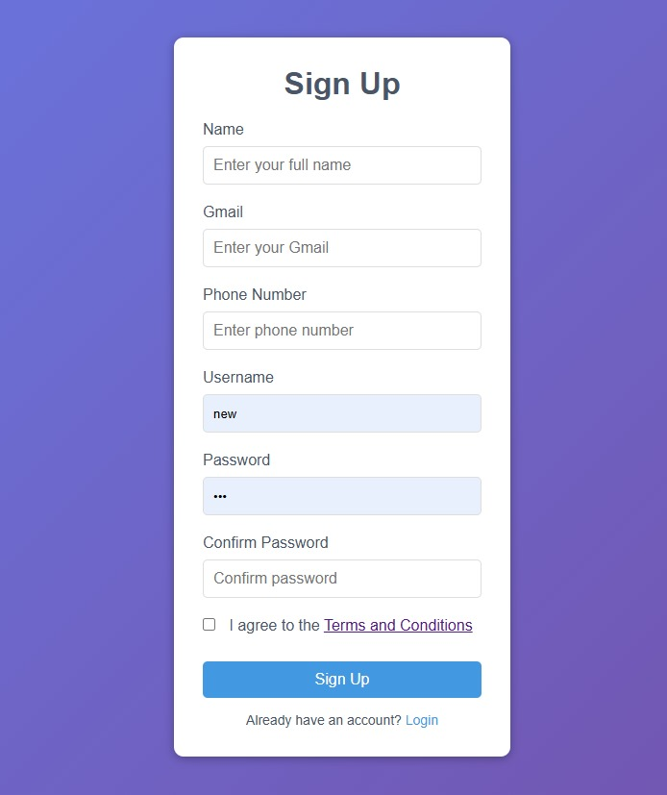

2)STEP 2: (Terms and Condition)

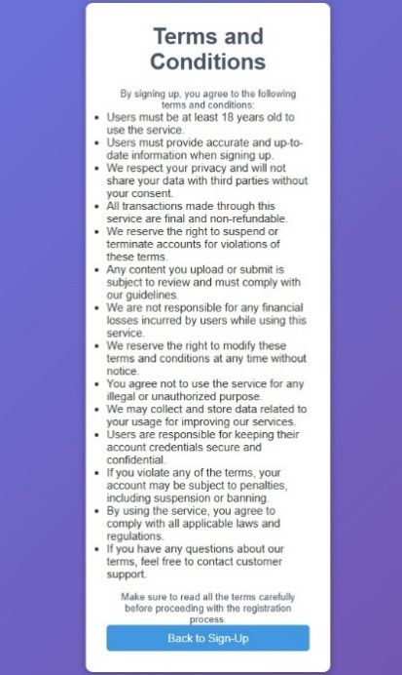

3)Step 3:(Login Page)

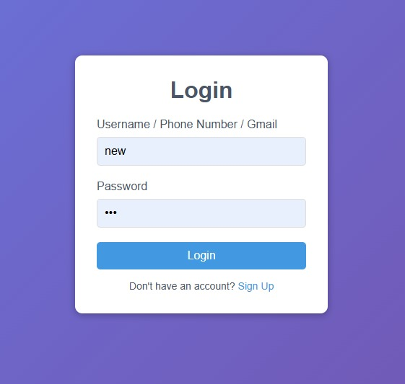

4)STEP 4:(Container To Store Entries)s

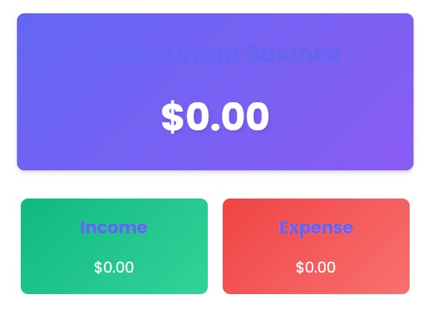

5)STEP 5:(Main Page – both Themes)

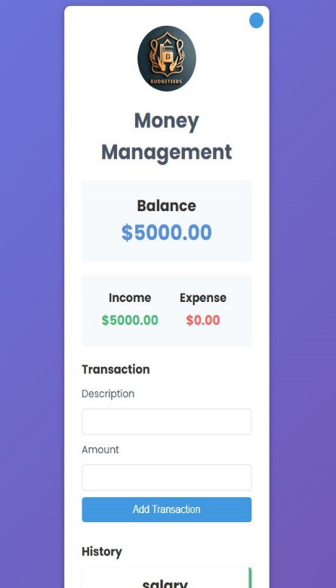 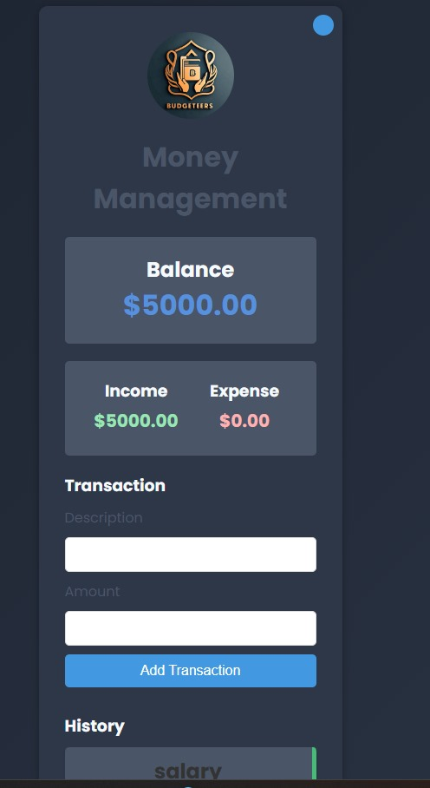

Applications

Money Managent through Website have several applictions

**1.Young Professionals & Students:** For young professionals and students,it manages budgets,save,invest and achive financial indepednce

**2.Families and Senior citizen’s:** for families and seniors,it helps manages households budget,plan for retirement,save for emergencies,save for emergencies and ensures financial security.

**3.House wife and Businesses:** For Housewife and Businesses, it simplifies household budgeting,tracks expenses,boosts savings and aids in managing business finances effectively.

Future Scope

To enhance the effectiveness of the money management model, the following future improvements are proposed:

1. **Expansion of Features:** Introduce web tool for financial planning tools for personalized budgeting and investment advice.

2. **Collaborations:** Partner with banks and financial institutions for seamless

transactions and financial products.

3. **Real-Time Alerts:** Notifying users about overspending or upcoming bills, helping . maintain control finances.

4. **Educational Tools:** Offering daily financial tips, improving financial literacy for . . better decision-making.

Conclusion

In conclusion, this money management project aims to empower individuals from various demographics—young professionals, students, families, seniors, housewives, and businesses—by providing tools and resources for effective financial planning. It encourages smarter budgeting, saving, and investing, fostering financial literacy and stability. Through personalized advice, real-time tracking, and educational content, users can make informed financial decisions that lead to long-term security and growth. Ultimately, the project helps users build a solid foundation for financial independence and a more secure future.

## References

1. **Mint** – Budgeting and financial planning tool: <https://www.mint.com>
2. **Investopedia** – Financial education and investment resources: <https://www.investopedia.com>/
3. **NerdWallet** – Financial advice and tools: <https://www.nerdwallet.com>
4. **Dave Ramsey** – Personal finance and budgeting resources: <https://www.daveramsey.com>
5. “Fake News Detection on Social Media: A Data Mining Perspective,” IEEE

Transactions on Knowledge and Data Engineering (Relevant research paper)

